***Chapter 5.***

# Input/ Output & Interface Design

**5.1SystemActivityDiagram**

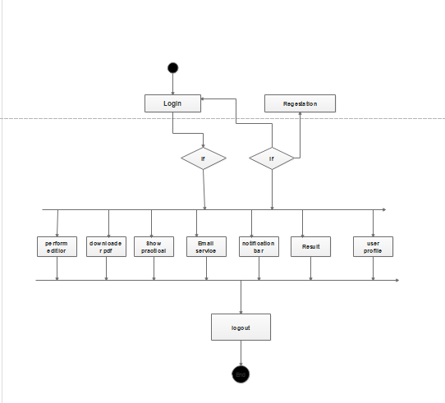





**5.2SystemProceduralDesign:**

5.2.1DesigningPseudocodeor algorithm for Method or operations

* Pseudo code is a kind of structured English for describing algorithm.
* It allows the designer to focus on the logic of the algorithm without begin distracted by details of language syntax.
* At the same time, the pseudo code needs to be complete.
* The “structured ” part of pseudo code is a notation for representing six specific structured programming constructs.
* These construct represent the logic, or flow of control in an algoritham.
* It has been proven that three basic constructs for flow of control are sufficient to implements any “proper” algorithan.

**Algorithm:**

**Step 1:**

If home = true

Then display menu

End if

**Step 2:**

If login form = true

Then open to the login form

End if

**Step 3:**

If login = true

Then display to the editior

End if

**Step 4:**

If profile = true

Then display to the user profile

End if

**Step 5:**

If faculty login form = true

Then open to the faculty login form

Else if login = true

Then faculty can send to the practical

End if

**Step 4:**

If practical. Course = user. course

Then show to the notification

and clicked to the download to the practical